Appendix X New Features in v2.4 B
Version 2.4B adds several features, which we have grouped into these categories:

New Suspension Types or Options
The program now allows for solid front axles and for several ways of locating them. Also included are calculations showing the drive shaft angle or U joint angle changes with suspension movement. Fig 6.33.

The program has 2 new steering options:
- One is where the steering is a steering box, there is no center link. Instead the tie rod on the spindle from one side is tied directly to the steering box arm. Then the tie rod from the other spindle is effectively tied to spindle that the steering link is attached to. This is the steering of some Jeep solid axle front suspensions. Fig 6.34.
- The second is where the steering is a steering box, but the tie rods do not attach to the center link. Instead they attach to arms on the steering box and idler arm on arms on opposite side of the center link arms. This is the steering of some Alfa Romeo suspensions. Fig 6.35.
You can now use a panhard bar or a watts link with leaf springs as the Lateral Locator. Fig 6.36. The program has new inputs in Vehicle Specs for:
- Front, rear or all wheel drive, and what percent of the power is being delivered through the front drive tires. Fig 6.37.
- The program has a new input in Vehicle Specs for inputs or inboard or outboard brakes at either the front or rear suspension. Fig 6.37.
- Unsprung weight is now an input for front and rear and is used to determine natural frequencies and some handling characteristics. Prior to this, the program assumed a certain percent of the vehicle’s weight was unsprung. Fig 6.37.

There is a Calculation Utility “Clc” screen for entering in inputs for the King Pins for solid axle front suspensions. Fig 6.38.

The program now allows you to specify what the opposite end of the car is doing. This lets you apply "pitch" to the car to see what happens to the calculations. Fig 6.39.

You can now enter specs for bump springs for the front and/or the rear suspension. (This feature is not available for push or pull rod type suspensions.) There is also a Clc screen to calculate these specs, which can be handy if you are working with “stacked” springs. Fig 6.40.

The program now calculates and displays new outputs, like Bump Spring Force and Dynamic (after dive and roll are applied) Roll Stiffness, Roll Couple, Front and Rear Lateral Load Transfer, and Natural Frequencies. This is very handy to watch what happens once the Bump Springs are encountered with suspension movement. Fig 6.40.

There are new inputs for Ride Height. You can then watch Ride Height change when you apply Bump and Roll and the new Pitch input to the suspension. When you do a top view of the suspension, the location where the Ride Height measurements are made are drawn as small boxes. These measurement locations are located in the Vehicle Specs screen, as they always have been. Fig 6.41.

New Graph, Report or Print Features
If you have swapped graph axes, like camber on the horizontal axes and movement on the vertical axes, and use the cursor, it is horizontal. Fig 6.46.

You can now include a picture file with the suspension which will be drawn on the main screen if there is room, and included in printouts of reports or graphs as you direct. Fig 6.47 and 6.49.

The program has new print options for graphs and reports of including the suspension picture file (if any). Fig 6.48.

You can now include the data table with a graph. Fig 6.49.

The printed Graph comments have new options and are described under File, then Printed Comments in the Graph Screen. Fig 6.49.

You can now graph the Jacking Component, Bump Spring Force, and Ride Height. Fig 6.47.

The Data Type you have picked to graph is now displayed under the list. Since the list is long and only the first picked data type is graphed, many times a type could be picked that you did not see in the list. Fig 6.47.

Other New Program Features
The program now reads some types of Bill Mitchell’s WinGeo (.gem) files, like double a arm and MacPhearson strut. Fig 6.43. There have been several updates to Emailing Preferences to work better with modern changes to emailing protocols. Fig 6.44. File Comments are now shown on the main screen if there is enough room. Fig 6.33.
Zoom options for the drawing on the main screen are now included under the "View" menu button options. The program now draws the CG in side view. Fig 6.39.
'The program now remembers some inputs you have entered in the "Clc" calculation utility screens, like for spring rate, roll
'bar rate, and the new Unsprung Weight, and more. These are saved with the file, so in the future you will know where, say, the roll bar rate came from. Fig 6.45.

The program now remembers the size and position of the main screen when you restart the program. This way, when you reopen the program, it should revert right back to the same position or size you last arranged.

The “Advanced” button for Save As now uses current folder as the default folder.

The program now better draws extension lines when the lines extend WAY OFF the drawing screen so as to look more realistic. The program now marks invalid solid front suspensions as "na" in the Vehicle Specs screen.
The Company Logo graphic now appears on the main screen. Fig 6.33.

The program now has substituted “Bump Springs” for "Symmetric Chassis" in the Vehicle Specs screen. This Symmetric Chassis feature was never activated in earlier versions.

Program now more reliably saves and reads its configuration info so the config file is less likely to get corrupted.

If the Registered Name or Registered Code becomes corrupted, the program now allows an easy fix by contacting Performance Trends.
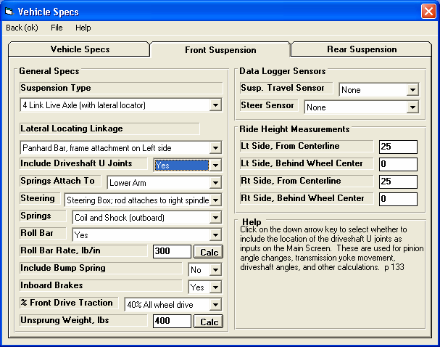
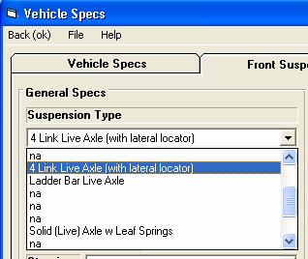
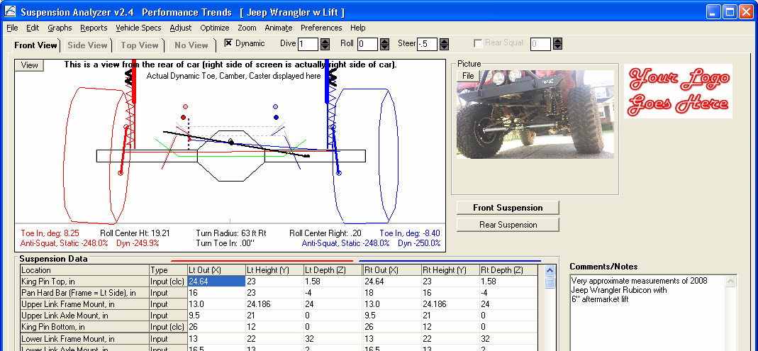
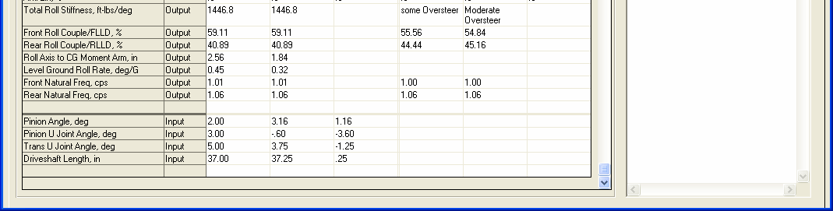
Figure A 6.33 New Solid Axle Front Suspension Options

Solid Axle options for Front Suspension, some of which are listed in figure below.

This setting determines if front or all wheel drive.

King pin.
Differential drawn if front or all wheel drive

Comments now on main screen.

Driveshaft and U joint angle info for front or all wheel drive now in new location at bottom of the report.
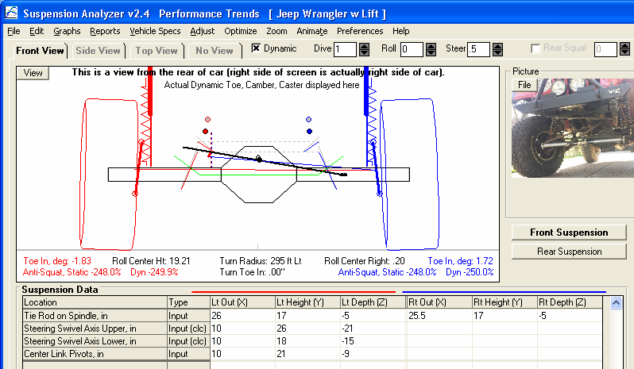
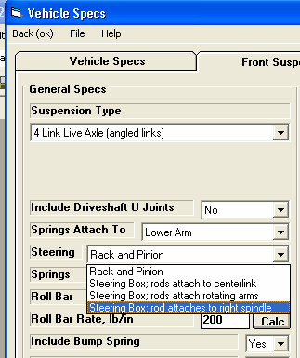
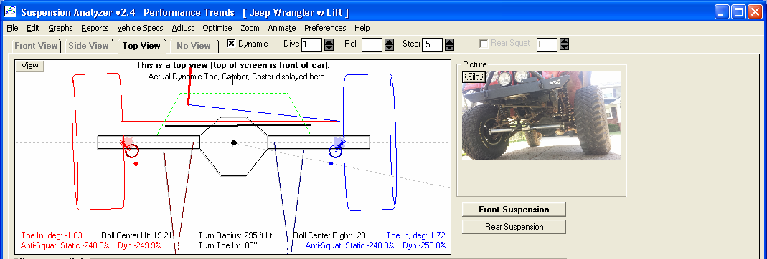
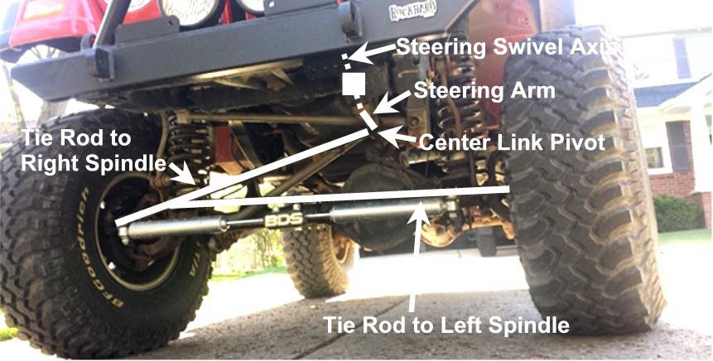
Figure A 6.34 New Steering System Option, “Steering Box, rod attaches to right spindle”
2 new steering options, this one common on Jeeps
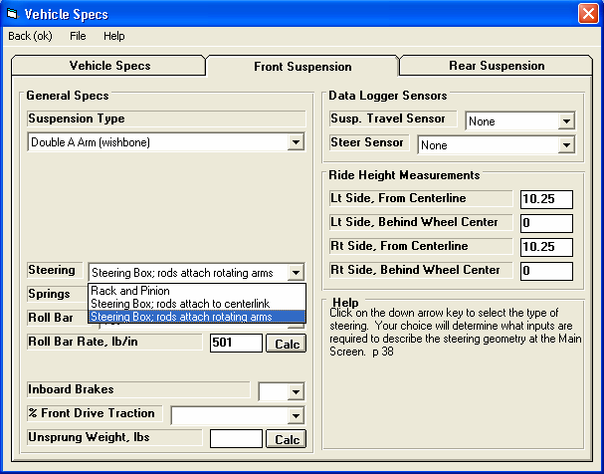
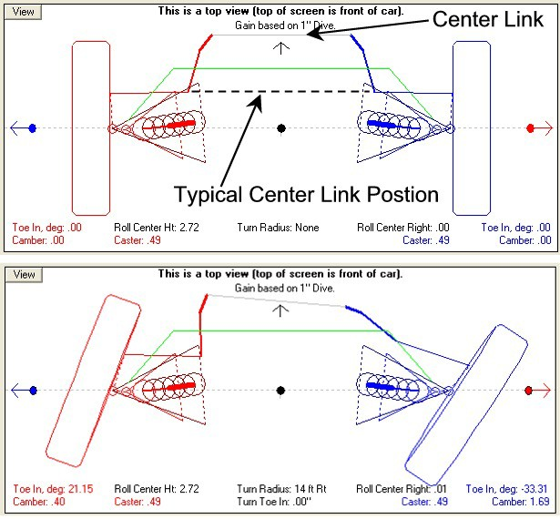
Figure A 6.35 New Steering System Option, “Steering Box: Rods attach to rotating arms”

This steering system is common on Alfa Romeo
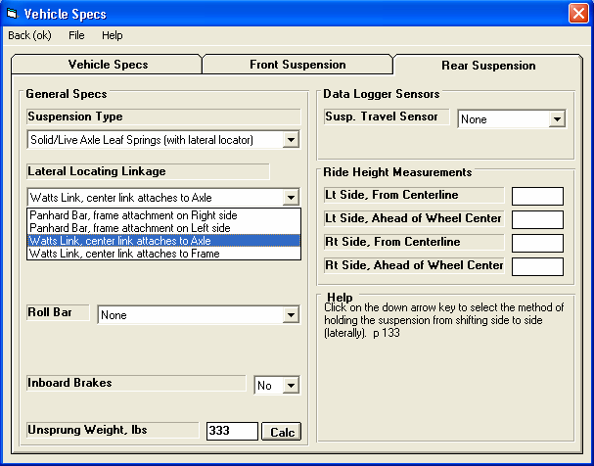
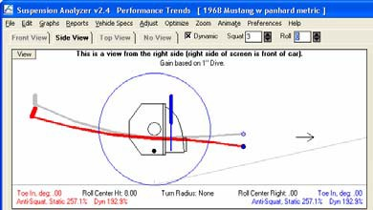
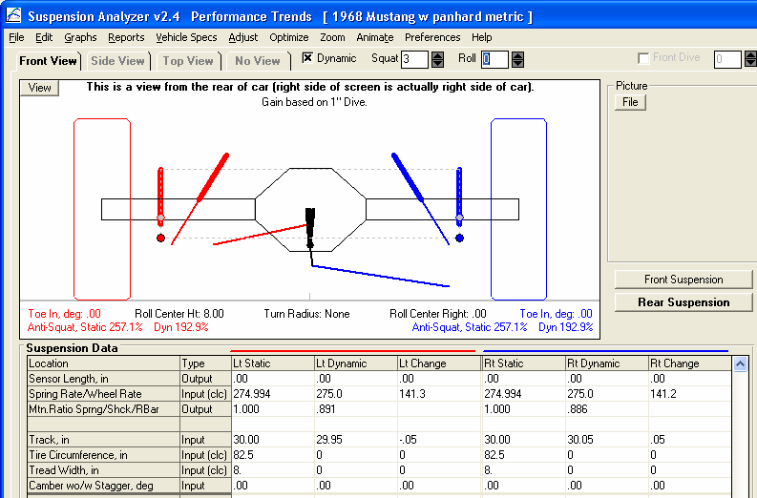
Figure A 6.36 Leaf Springs now allow for Lateral Locators, Panhard Bar or Watts Link
Choose this new “Leaf Spring (with lateral locator)” option for the “Lateral Locating Linkage” options to appear.

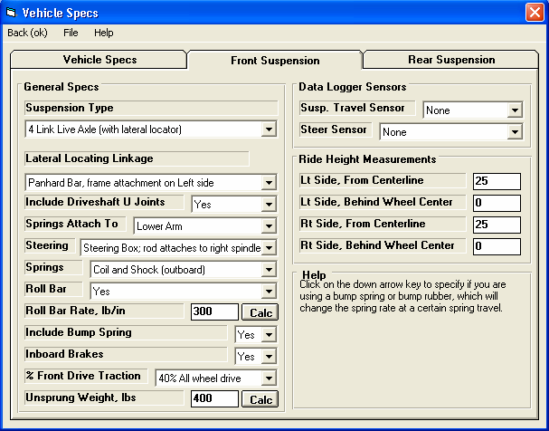
Figure A 6.37 More Inputs for Vehicle Specs
Unsprung weight will affect Natural Frequency and some handling calculations. Click on the “Calc” button to calculate from other inputs.
% Front Drive Traction will affect Anti-Lift calculations.
Inboard vs Outboard brakes will affect Anti-Dive calculations.
Bump Springs as described in Fig 6.40.
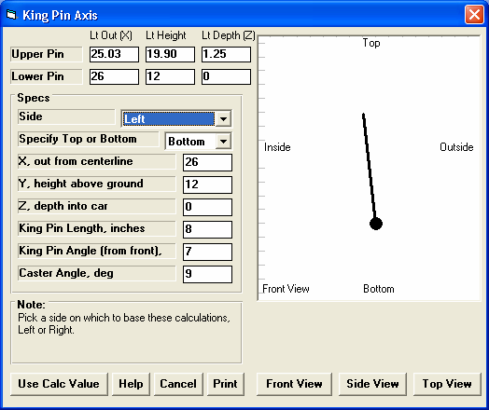
Figure 6.38 Calculation “Clc” Utility to Calculate King Pin Settings from Angles
Choose a side, then enter inputs to see the king pin angle being drawn. The large “dot” is showing the “Specify Top or Bottom” end of the king pin. Click on the “View” buttons at the bottom to see the king pin from different angles. King Pin Length is not very critical, as it is mostly used for the drawing. The critical thing for the calculations are the angles you have entered.
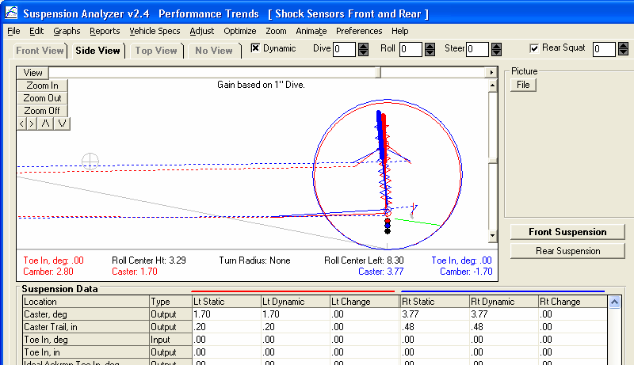
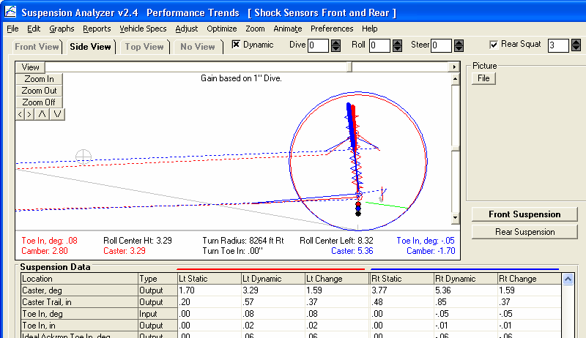

Figure A 6.39 Applying Pitch to Suspension Movement
Check here to turn on this option.

CG is drawn
Then choose movement for other end of the car vs “Dive” on front end.

CG is lower
Note how drawing is updated with 3” rear squat.

Note how calculations have been changed (significant caster change), with no motion on the front suspension, but only movement on the rear suspension.
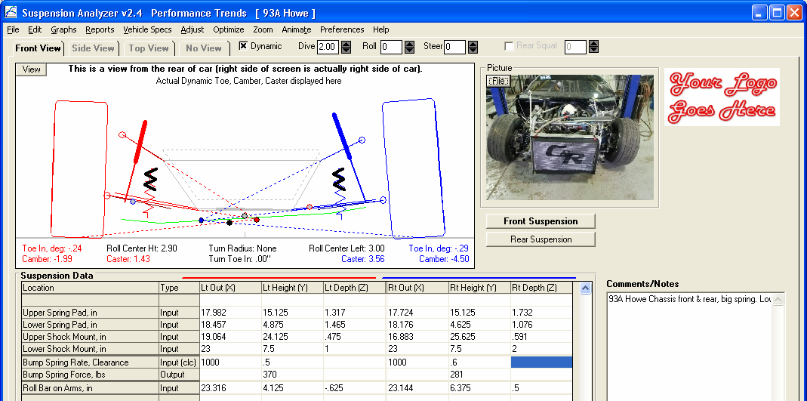
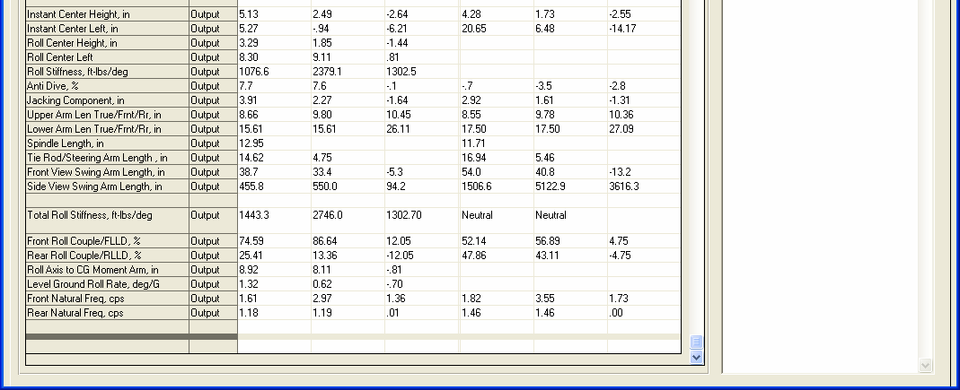
Figure 6.40 New Inputs of Bump Springs
If you are using Bump Springs, heavier black coils are drawn on the top of the springs.

Bump spring inputs go here, with the spring rate (lb/in) first, and Clearance (distance suspension spring must compress before encountering the bump spring) coming second. In the case shown, 1000 lb/in are the rates and .5 and .6 inches are the Clearances.
The force being produced just by the Bump Spring, in lbs.
Roll Stiffness increases from 1077 to 2379 as the Bump Springs are encountered, in this case of 2” of dive.

The change in many other handling ratings are shown here, with the static rating at static ride height shown first, then the new rating at the new dynamic condition (in this case 2” dive), and then the amount of change. For example, the FLLD% changed from 52.14% to 56.89% with 2” of dive, a 4.75% change. But the “rating” is still considered “Neutral” for both.
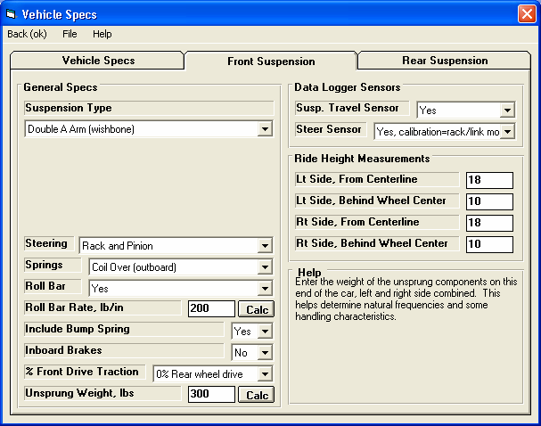
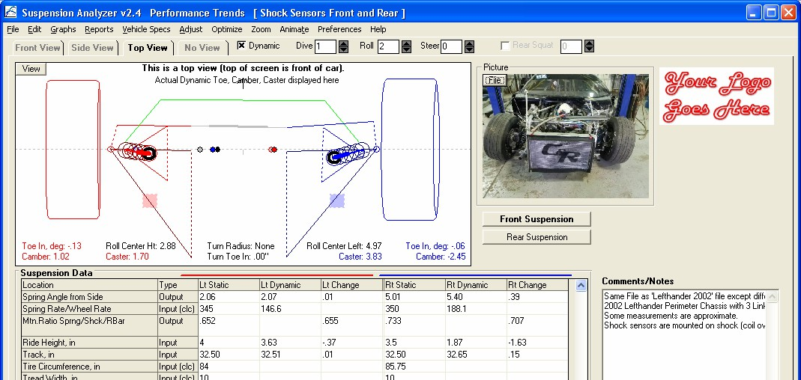
Figure 6.41 New Inputs of Ride Height

In Vehicle specs, the location where Ride Height is measured can be entered here.

In “Top View”, the location where Ride Height is measured (as entered in the screen shown above) is shown by a light red and light blue box.

You will enter the Static Ride Height (typically the clearance between the ground and the vehicle’s frame) in the first column. Then the new Dynamic Ride Height (clearance) is displayed in the second column, with the difference in the third. In this case, the Left side Ride Height changed from 4 to 3.63 with 1” of dive and 2 deg of roll, a change of -.37 inches.

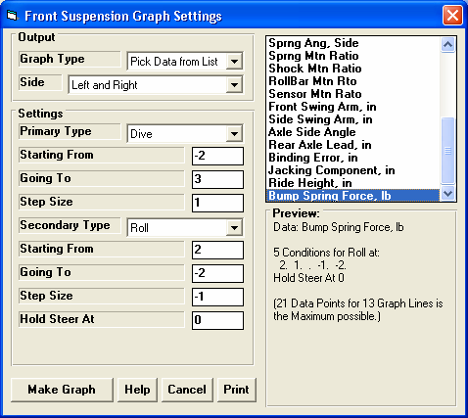
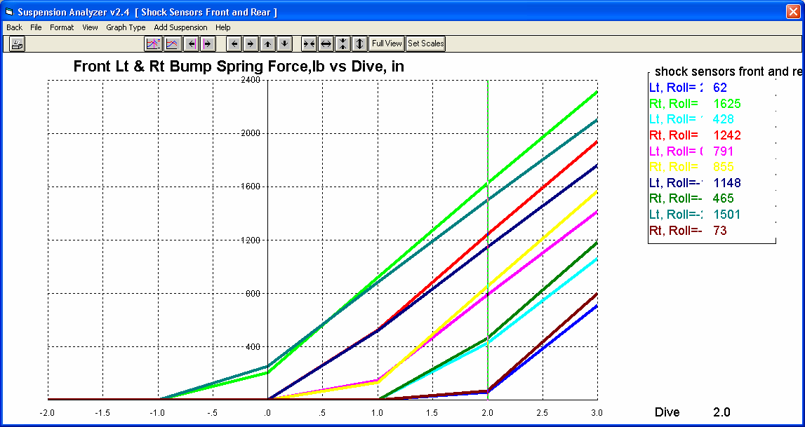
Figure 6.42 New Data Type Options for Graphs and Reports
The first chosen Data Type is shown here, which is the Data Type which will be graphed.
Three new Data Type options for graphs and reports appear on the bottom of this list.
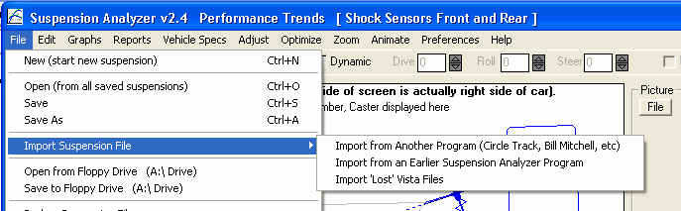
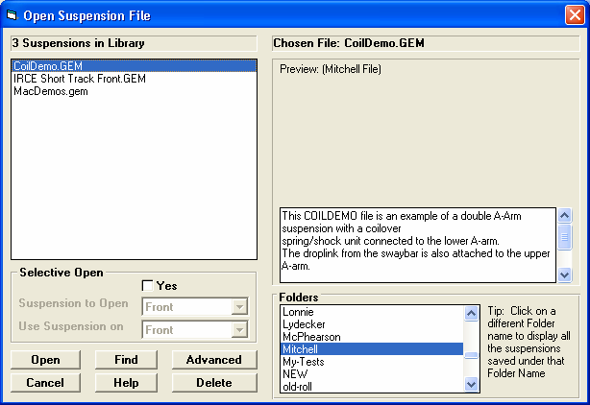
Figure 6.43 New Option of Importing Bill Mitchell Win Geo Files
If the Suspension Analyzer recognizes the file as Bill Mitchell, it will be displayed here as “Mitchell File”.
You can click on “Open” or “Import” to bring up the Open Suspension File screen shown below. Then locate and click on the Bill Mitchell file, typically with a .GEM file extension.

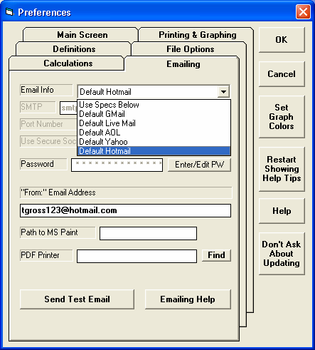
Figure 6.44 New Preference Settings for Emailing Results
Click on Help button for more information on these Emailing preferences.
Click on Emailing tab in Preferences screen.

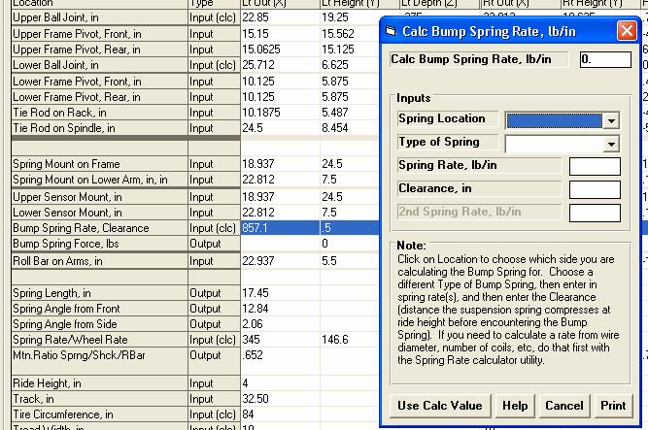
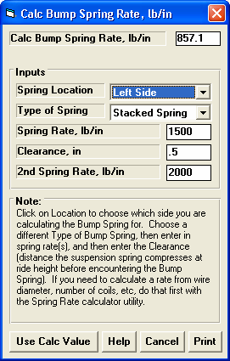
Figure 6.45 Program Now Remembers Inputs Used for Calculation “Clc” Utility Screens
Click here to bring up a “Clc” screen, in this case for a Bump Spring.

When the screen is first opened, it may be blank, especially if something can be calculated for either the left or right side, as is the case here.
Once you pick a “Location” the inputs for the last time this screen was used for this file will be filled in. If you open a different file, these inputs could be different or blank.

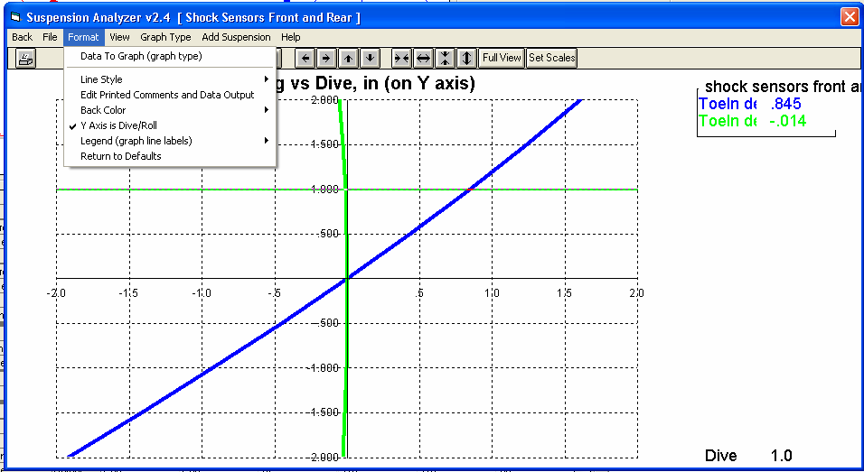
Figure A 6.46 Horizontal Cursors
The values at the horizontal cursor are displayed here.
If you are doing “Y Axis is Dive/Roll” type of graph and click on a graph line, the cursor is now drawn horizontally.
If you have chosen “Y Axis is Dive/Roll”, the graph may look more like a typical “bump steer” graph like you are used to.
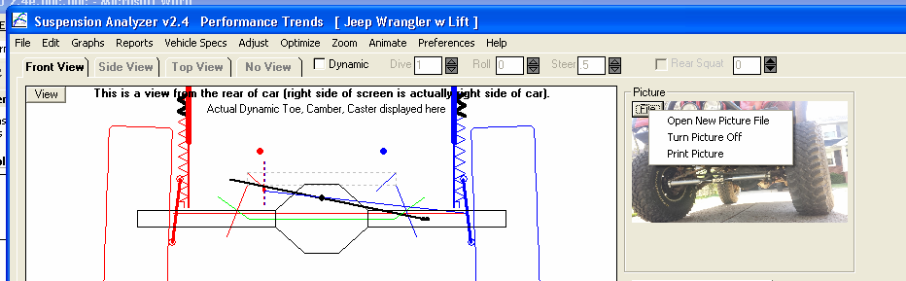
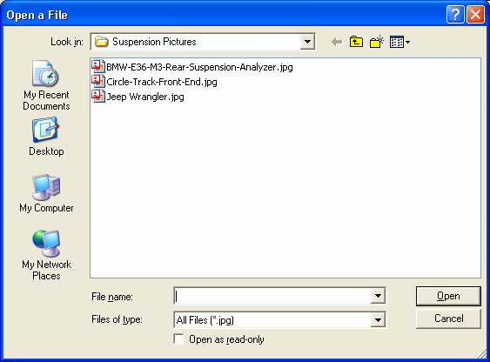
Figure A 6.47 Picture Files
Click on the Picture File button for these options. Click on the Open option for the standard “Open a File” screen shown below. There you can browse to any place on your computer to pick a picture file.

NOTE: The only thing saved in the suspension file is the location and name of the picture file, not the actual file. So, if you copy a suspension file to a different computer and the picture file is not also copied and placed in the same folder on the new computer, it will not appear on the new computer.
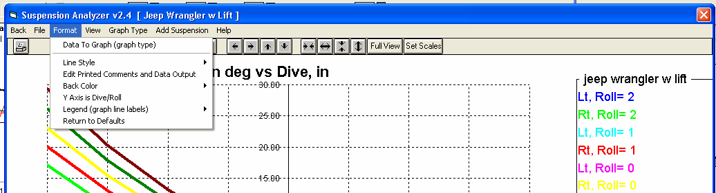
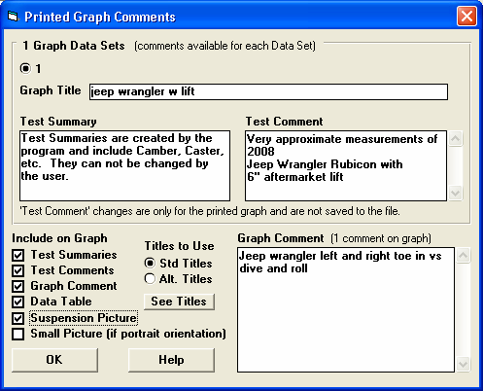
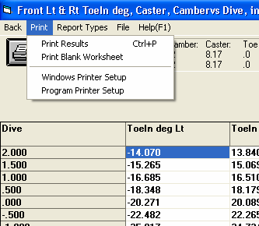
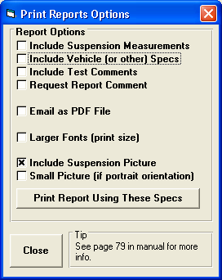

Figure 6.48 New Options for Printing Graphs and Reports
In the Graph screen, click on Format, then “Edit Printed Comments and Data Output” for the options screen shown below.

This screen contains many options for customizing and adding information to your printed graphs. See Fig 6.49.

In the Report screen, click on Print then Program Printer Setup for the screen shown on the right, which contains several options for customizing printed reports.
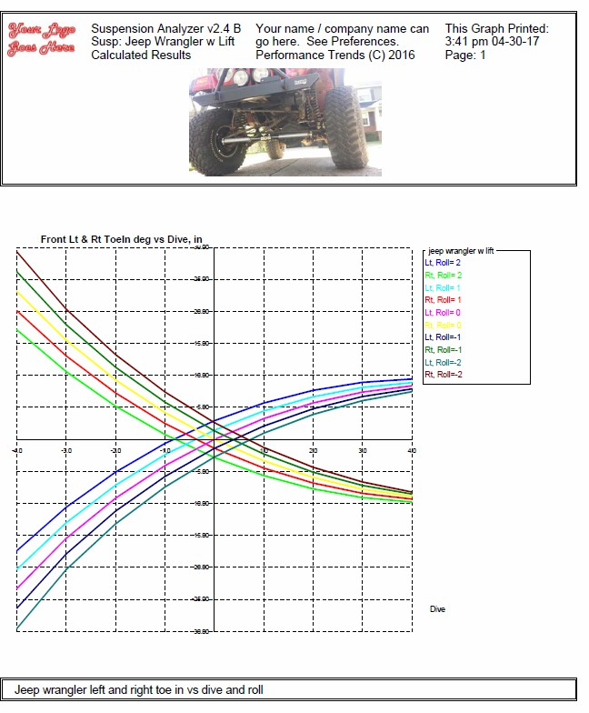
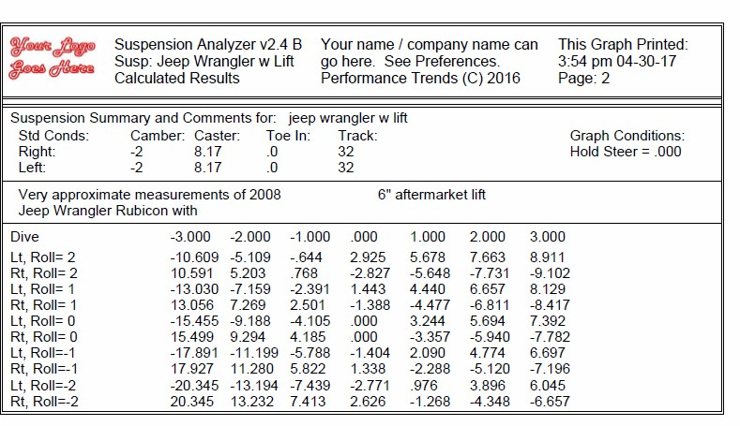
Figure 6.49 New Options on a Graph Printout
Suspension picture file included on the graph printout.

Graph Comment

Test Summary
Test Comment

Data Table

